Registration for 2026/2027 Faith Formation (Grades K-7)

Registration for First Sacrament Preparation (Penance and Eucharist)
and for Confirmation Preparation (Years 1 and 2) will be done separately.

RETURN COMPLETED FORM AND PAYMENT TO:
Holy Trinity Church | Attn: Neil D’Alessandro | 1460 Ridge Road | Webster, NY 14580
Check made out to Holy Trinity Church

Space is limited in our Sunday Program and grades will close once classroom capacity is reached.
Family Program will remain open to all new registrants.
**Sunday Program for Grades 6 and 7 will be meeting Sunday EVENING at 6:30pm in Peace and Unity**

Mother’s Name (include maiden name)

Mother’s Cell # ___________________ Email

Father’s Name

Father’s Cell # ____________________ Email

Home Address of Student(s)
Street Address Town Zip

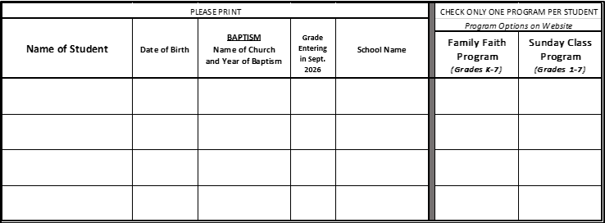

Material Fee: $70 per student; $175 max per family (same household residence)
Payment due at time of registration. Checks payable to Holy Trinity Church.
Number of children enrolled: 1 2 3+
Total owed at registration: $70 $140 $175

Registration is not complete until payment is received.
If you are in financial need, please contact us for assistance.

REQUIRED MEDICAL AND MEDIA RELEASE ON REVERSE

For office use only: Ck. No. ________ Ck. Date ________ Ck. Amt. ________
HEALTH HISTORY

Please list any medical conditions that might affect your child(ren) participating in this program.

Does your child(ren) have any allergies or other dietary restrictions?
________________________________________________________________________________________________________________________________________________________________________________________________________________________________________________________________________________________________

Is your child(ren) currently taking any medications (prescription and /or non-prescription)? If so, please list.
________________________________________________________________________________________________________________________________________________________________________________________________________________________________________________________________________________________________

Is there anything else we should know about your child(ren), especially with regards to disability, neurodiversity, and/or necessary accommodations?
________________________________________________________________________________________________________________________________________________________________________________________________________________________________________________________________________________________________

EMERGENCY CONTACT and MEDICAL RELEASE INFORMATION

Emergency Contact (If parents cannot be reached.) __________________________________________________

Emergency Contact's Relationship to Child(ren) __________________________________________________

Emergency Contact's Cell Phone Number __________________________________________________

Primary Care Physician __________________________________________________

Primary Care Physician's Phone Number __________________________________________________

Release Statement:
I give permission for my child(ren) to be transported in a privately owned vehicle or emergency transportation for medical emergencies only and for the release of medical records to an attending health care professional in case of injury or illness. I understand that every effort will be made to contact the parent/guardian. If one cannot be contacted, I hereby give permission for a qualified physician to secure proper treatment for my child(ren). I certify that my child(ren) is in good health and has no limitations other than those I have listed, which may predispose him/her to risk during participation in the program.

Submitting this form confirms that I give permission for my child(ren) to participate in the program. I hereby release the Diocese of Rochester and all its affiliated entities, including its employees, volunteers, and parish sponsor from any and liability for any damages suffered as a result of or relating to my child(ren)'s participation in the program. I agree that neither the Diocese of Rochester or the parish sponsor will be responsible for reimbursement of copayments or uninsured medical costs.

PARENT SIGNATURE _______________________________________ DATE ___________________

MEDIA RELEASE

Regarding the use of photographs, slides, audiotapes, and/or videotapes of my children named above:

Holy Trinity Church (please check one below):

_____ HAS permission to photograph or video my child(ren) during the 2026/27 Faith Formation Program or related activities. Such media may be shared with our parish community through church bulletins, emailed newsletters, live video feed and social media, etc. Full names of minors will not be used in conjunction with photographs or video.

_____ DOES NOT have permission to photograph or video my child(ren) during the 2026/27 Faith Formation Program except if my child’s face is indistinguishable (i.e. turned away from the camera or otherwise unidentifiable).

PARENT SIGNATURE _______________________________________ DATE ___________________

